Project Design Phase-II
Technology Stack (Architecture & Stack)

Date | 30 September 2026
Team ID | SWTID-2026-5468
Project Name | Implement Client Script & UI Policy (Incident)
Maximum Marks | 4 Marks

Technical Architecture:
The Deliverable shall include the architectural diagram as below and the information as per the table1 & table 2
Example: Order processing during pandemics for offline mode
Reference: https://developer.ibm.com/patterns/ai-powered-backend-system-for-order-processing-during-pandemics/
Guidelines:
Include all the processes (As an application logic / Technology Block)
Provide infrastructural demarcation (Local / Cloud)
Indicate external interfaces (third party API’s etc.)
Indicate Data Storage components / services
Indicate interface to machine learning models (if applicable)


Table-1 : Components & Technologies:
S.No | Component | Description | Technology
 | User Interface | Incident form (Incident → Create New / Open) and Incident list view (Incident → All) where users enter, update and edit records | ServiceNow Platform UI (Now Platform)
 | Application Logic-1 | UI Policy "High Impact Control" (System UI → UI Policies): condition Impact is 1 - High; Assignment group mandatory; Reverse if false = true | ServiceNow UI Policy
 | Application Logic-2 | UI Policy Action on Urgency (Read-only = true) and onChange client script on Impact that sets Urgency to High and shows an info message | ServiceNow UI Policy Action; Client Script (JavaScript, g_form)
 | Application Logic-3 | onSubmit client script that blocks saving when Impact is High and Assigned To is empty, and onCellEdit client script that blocks State changes in the list | Client Scripts (JavaScript: onSubmit, onCellEdit)
 | Database | Incident records with Impact, Urgency, Assigned To, Assignment group and State fields stored in the incident table | ServiceNow Now Platform database
 | Cloud Database | Database is hosted and managed as part of the ServiceNow cloud instance; no separate database setup is needed | ServiceNow cloud instance
 | File Storage | Not required for this project; no files are created or stored by the UI Policy or Client Scripts | Not applicable
 | External API-1 | Not used; all logic runs inside the ServiceNow instance | Not applicable
 | External API-2 | Not used | Not applicable
 | Machine Learning Model | Not used; rules are fixed conditions on field values | Not applicable
 | Infrastructure (Server / Cloud) | Configuration and testing done on a ServiceNow instance in the cloud, using an account with administrative or configuration access | ServiceNow cloud instance (Now Platform)

Table-2: Application Characteristics:
S.No | Characteristics | Description | Technology
 | Open-Source Frameworks | No open-source frameworks are used; the solution relies on native ServiceNow client-side features (UI Policies and Client Scripts) and the g_form API | ServiceNow UI Policies, Client Scripts
 | Security Implementations | Rules are created and changed only with administrative or configuration access; incident access follows standard ServiceNow roles and access controls; save-time validation prevents incomplete high impact records | ServiceNow roles and access controls
 | Scalable Architecture | Rules are defined once on the Incident table and apply to all records; they run in the user's browser, so no extra server load or setup as incidents grow | ServiceNow Now Platform, client-side scripting
 | Availability | Controls are part of the instance configuration and are available whenever the Incident form and list are available; no external dependency | ServiceNow cloud instance
 | Performance | Client-side checks respond immediately without a server round trip; scripts are short and run only for specific fields and events | Client Scripts, UI Policy

Project Technical Architecture:
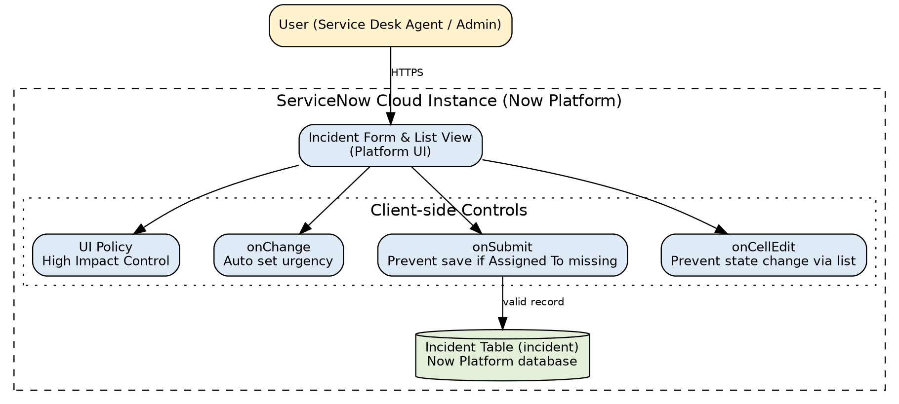
Architecture Flow:
• The user opens the Incident form or list in the browser over HTTPS.
• The UI Policy evaluates Impact and applies field behaviour (Assignment group mandatory, Urgency read-only) and reverses it when the condition is no longer met.
• The onChange script sets Urgency to High and shows an info message when Impact changes to High.
• The onSubmit script checks Impact and Assigned To when the user saves, and stops the save with an error message if the data is incomplete.
• The onCellEdit script blocks State edits made from the list view.
• Only records that pass these checks are saved to the incident table.

References:
https://c4model.com/
https://developer.ibm.com/patterns/online-order-processing-system-during-pandemic/
https://www.ibm.com/cloud/architecture
https://aws.amazon.com/architecture
https://medium.com/the-internal-startup/how-to-draw-useful-technical-architecture-diagrams-2d20c9fda90d

